

ASSIGNMENT-1
Assignment Title: E-Commerce Order Management System

Submitted by: N . Sudheer Registration number: 192525087
Guided by: Mohan A Course code/name: Csa0914 - Programming In Java

Problem Statement
A leading e-commerce company receives thousands of customer orders every day through its online platform. Managing customers, products, inventory, orders, payments, and order status manually can result in stock inconsistencies, invalid transactions, and delays in order processing.
The proposed E-Commerce Order Management System is a Java-based application designed to automate the complete order management process. The system allows customers to view products, place orders, make payments, and track order status. It also enables administrators to manage customers, products, inventory, orders, and transactions.
The application uses Object-Oriented Programming, Collection Framework, Exception
Handling, Multithreading, Synchronization, AWT Event Handling, Java I/O,
Serialization, and JDBC. Synchronization is used while updating inventory so that multiple customers purchasing the same product simultaneously do not cause incorrect stock values.

Source Code
package com.ecommerce;

import com.ecommerce.database.DatabaseInitializer; import com.ecommerce.gui.LoginFrame; import com.ecommerce.model.CardPayment; import com.ecommerce.model.Cart; import com.ecommerce.model.Customer; import com.ecommerce.model.Order; import com.ecommerce.model.Payment; import com.ecommerce.model.PaymentStatus; import com.ecommerce.model.Product; import com.ecommerce.model.UPIPayment; import com.ecommerce.model.User; import com.ecommerce.model.UserRole; import com.ecommerce.service.AuthenticationService; import com.ecommerce.service.CustomerService; import com.ecommerce.service.InventoryService; import com.ecommerce.service.OrderService; import com.ecommerce.service.ProductService; import com.ecommerce.service.ReportService; import com.ecommerce.test.ConcurrentOrderTest; import com.ecommerce.test.TestSuite; import com.ecommerce.util.LoggerUtil;

import java.util.List; import java.util.Scanner;

/**
- Main Application Entry Point for the Core Java E-Commerce Order Management System.
- Supports:
- 1. Java AWT Desktop GUI Interface (Default / GUI Mode)
- 2. Interactive Terminal Console Interface
- 3. Automated Concurrency Demonstration (Section 32)
- 4. Master 24-Scenario Test Suite Execution
*/
public class Main {

private static final AuthenticationService authService = new AuthenticationService(); private static final ProductService productService = new ProductService(); private static final InventoryService inventoryService = new InventoryService(); private static final CustomerService customerService = new CustomerService(); private static final OrderService orderService = new OrderService(); private static final ReportService reportService = new ReportService();

public static void main(String[] args) {

System.out.println("================================================================= ===============");
System.out.println(" E-COMMERCE ORDER MANAGEMENT SYSTEM USING CORE JAVA
");

System.out.println("================================================================= ===============");

// 1. Initialize Database Schema & Seed Data
try {
DatabaseInitializer.initializeDatabase();
LoggerUtil.getLogger().info("System database initialized successfully.");
} catch (Exception e) {
System.err.println("Fatal Error initializing database: " + e.getMessage()); e.printStackTrace(); return;
}

// Check command line flags
if (args.length > 0) {
String mode = args[0].toLowerCase(); if ("--test".equals(mode) || "-t".equals(mode)) { TestSuite.runAllTests(); return;
} else if ("--concurrency".equals(mode) || "-c".equals(mode)) { ConcurrentOrderTest.runTest();
return;
} else if ("--gui".equals(mode) || "-g".equals(mode)) { launchAwtGui(); return;
}
}

// Run Interactive CLI Console by default, offering GUI launch option runConsoleMenu();
}

public static void launchAwtGui() {
System.out.println(">>> Launching Java AWT Desktop User Interface..."); java.awt.EventQueue.invokeLater(new Runnable() {
@Override public void run() {
try {
LoginFrame loginFrame = new LoginFrame(); loginFrame.setVisible(true);
} catch (Exception e) {
System.err.println("Failed to open AWT GUI: " + e.getMessage());
}
}
});
}

private static void runConsoleMenu() { Scanner scanner = new Scanner(System.in); boolean running = true;

while (running) {
System.out.println("\n=== E-COMMERCE ORDER MANAGEMENT SYSTEM ===");
System.out.println("1. Customer Login");
System.out.println("2. Customer Registration");
System.out.println("3. Admin Login");
System.out.println("4. Launch Java AWT Desktop GUI");
System.out.println("5. Run Master Test Suite (24 Tests)");
System.out.println("6. Run Multi-Threaded Concurrency Test (Section 32)");
System.out.println("7. Generate Business & Sales Reports");
System.out.println("8. Exit Application");
System.out.print("Select an option (1-8): ");

String choice = scanner.nextLine().trim();

switch (choice) { case "1":
handleConsoleCustomerLogin(scanner); break; case "2":
handleConsoleCustomerRegistration(scanner);
break; case "3":
handleConsoleAdminLogin(scanner); break; case "4": launchAwtGui(); break; case "5":
TestSuite.runAllTests();
break; case "6":
ConcurrentOrderTest.runTest(); break; case "7":
generateReportsConsole();
break; case "8":
System.out.println("Exiting E-Commerce Order Management System. Goodbye!"); orderService.shutdownWorkers(); running = false; System.exit(0); break; default:
System.out.println("Invalid option. Please choose between 1 and 8.");
}
}
}

private static void handleConsoleCustomerLogin(Scanner scanner) {
System.out.print("Enter Customer Username: ");
String username = scanner.nextLine().trim();
System.out.print("Enter Password: ");
String password = scanner.nextLine().trim();
try {
User user = authService.login(username, password); if (user.getRole() != UserRole.CUSTOMER) {
System.out.println("Error: Account is not a Customer account. Use Admin Login.");
return;
}
Customer customer = (Customer) user;
System.out.println("Login Successful! Welcome, " + customer.getName()); runCustomerConsoleDashboard(scanner, customer);
} catch (Exception e) {
System.out.println("Login Failed: " + e.getMessage());
}
}

private static void handleConsoleCustomerRegistration(Scanner scanner) {
try {
System.out.print("Choose Username: ");
String username = scanner.nextLine().trim();
System.out.print("Choose Password: ");
String password = scanner.nextLine().trim();
System.out.print("Full Name: ");
String name = scanner.nextLine().trim();
System.out.print("Email Address: ");
String email = scanner.nextLine().trim();
System.out.print("Phone (10 digits): ");
String phone = scanner.nextLine().trim();
System.out.print("Shipping Address: ");
String address = scanner.nextLine().trim();

Customer created = authService.registerCustomer(username, password, name, email, phone, address);
System.out.println("Registration Successful! Welcome, " + created.getName() + " (ID: " + created.getCustomerId() + ")");
} catch (Exception e) {
System.out.println("Registration Failed: " + e.getMessage());
}
}

private static void handleConsoleAdminLogin(Scanner scanner) {
System.out.print("Enter Admin Username (default: admin): ");
String username = scanner.nextLine().trim();
System.out.print("Enter Admin Password (default: admin123): ");
String password = scanner.nextLine().trim();
try {
User user = authService.login(username, password); if (user.getRole() != UserRole.ADMIN) {
System.out.println("Access Denied: Not an Administrative account.");
return;
}
System.out.println("Admin Authentication Successful! Welcome, Administrator."); runAdminConsoleDashboard(scanner);
} catch (Exception e) {
System.out.println("Admin Login Failed: " + e.getMessage());
}
}

private static void runCustomerConsoleDashboard(Scanner scanner, Customer customer) { Cart cart = new Cart(customer.getCustomerId()); boolean inSession = true;

while (inSession) {
System.out.println("\n=== CUSTOMER DASHBOARD ===");
System.out.println("1. View Products");
System.out.println("2. Search Product");
System.out.println("3. Add to Cart");
System.out.println("4. View Cart");
System.out.println("5. Place Order");
System.out.println("6. Payment & Checkout");
System.out.println("7. Track Order");
System.out.println("8. Order History");
System.out.println("9. Logout");
System.out.print("Select an option (1-9): ");

String choice = scanner.nextLine().trim();
try {
switch (choice) { case "1":
List<Product> products = productService.getAllProducts(); System.out.println("\n--- PRODUCT CATALOG ---"); for (Product p : products) {
System.out.printf("[%d] %-25s (%-11s) - $%-7.2f | Stock: %d%n",
p.getProductId(), p.getProductName(), p.getCategory(), p.getPrice(), p.getQuantity());
} break; case "2":
System.out.print("Enter product name search term: ");
String term = scanner.nextLine().trim();
List<Product> results = productService.searchProduct(term);
System.out.println("Found " + results.size() + " matching products:"); for (Product p : results) {
System.out.println(" - " + p.toString());
} break; case "3":
System.out.print("Enter Product ID to add: "); int pid = Integer.parseInt(scanner.nextLine().trim()); System.out.print("Enter Quantity: ");
int qty = Integer.parseInt(scanner.nextLine().trim()); Product prod = productService.getProduct(pid); cart.addProduct(prod, qty, inventoryService.getStock(pid));
System.out.println("Product added to cart! Cart Total: $" + cart.calculateFinalAmount()); break; case "4":
System.out.println("\n--- YOUR SHOPPING CART ---");
if (cart.isEmpty()) {
System.out.println("Your cart is empty.");
} else {
for (com.ecommerce.model.CartItem item : cart.getItems()) { System.out.println(" " + item.toString());
}
System.out.printf("Subtotal: $%.2f | Discounts: -$%.2f | Tax: +$%.2f | Total: $%.2f%n", cart.calculateSubtotal(), cart.calculateCategoryDiscounts(), cart.calculateTax(), cart.calculateFinalAmount());
} break; case "5": case "6":
if (cart.isEmpty()) {
System.out.println("Your cart is empty. Add products before checkout.");
break;
}
System.out.println("Order Total: $" + cart.calculateFinalAmount());
System.out.println("Select Payment Method: 1) Card 2) UPI 3) Cash On Delivery");
String pChoice = scanner.nextLine().trim();
Payment payment;
Order order = orderService.createOrderFromCart(customer, cart, customer.getAddress());

if ("2".equals(pChoice)) {
payment = new UPIPayment(0, order.getOrderId(), order.getTotalAmount(), customer.getUsername() + "@upi");
} else if ("3".equals(pChoice)) {
payment = new com.ecommerce.model.CashOnDeliveryPayment(0, order.getOrderId(), order.getTotalAmount(), customer.getAddress());
} else {
payment = new CardPayment(0, order.getOrderId(), order.getTotalAmount(), "4111222233334444", customer.getName(), "12/28", "123");
}

orderService.executeOrderDirect(customer, order, payment);
System.out.println(">>> SUCCESS: Order #" + order.getOrderId() + " placed and confirmed!"); cart.clearCart();
break; case "7": case "8":
List<Order> orders = orderService.getCustomerOrders(customer.getCustomerId()); System.out.println("\n--- ORDER HISTORY ---"); if (orders.isEmpty()) {
System.out.println("No past orders found.");
} else {
for (Order o : orders) {
System.out.println(" " + o.toString());
} } break; case "9":
inSession = false;
System.out.println("Logged out from Customer account.");
break; default:
System.out.println("Invalid choice.");
}
} catch (Exception e) {
System.out.println("Operation Error: " + e.getMessage());
}
}
}

private static void runAdminConsoleDashboard(Scanner scanner) { boolean inSession = true; while (inSession) {
System.out.println("\n=== ADMIN DASHBOARD ===");
System.out.println("1. View All Products");
System.out.println("2. Add Product");
System.out.println("3. Adjust Inventory Stock");
System.out.println("4. View All Orders");
System.out.println("5. Update Order Status");
System.out.println("6. View Registered Customers");
System.out.println("7. Generate All Reports to Disk");
System.out.println("8. Logout");
System.out.print("Select an option (1-8): ");

String choice = scanner.nextLine().trim();
try {
switch (choice) { case "1":
List<Product> products = productService.getAllProducts(); for (Product p : products) {
System.out.println(" " + p.toString());
} break; case "2":
System.out.print("Product Name: ");
String name = scanner.nextLine().trim();
System.out.print("Category (Electronics/Clothing/Grocery): ");
String cat = scanner.nextLine().trim(); System.out.print("Price: ");
double price = Double.parseDouble(scanner.nextLine().trim()); System.out.print("Stock: ");
int stock = Integer.parseInt(scanner.nextLine().trim());

Product np;
if ("Clothing".equalsIgnoreCase(cat)) {
np = new com.ecommerce.model.ClothingProduct(0, name, price, stock, "Admin Added", "Supplier", "AVAILABLE", "L", "Blue", "Cotton", "Unisex");
} else if ("Grocery".equalsIgnoreCase(cat)) {
np = new com.ecommerce.model.GroceryProduct(0, name, price, stock, "Admin Added", "Supplier", "AVAILABLE", "2027-12-31", true, "Ambient");
} else {
np = new com.ecommerce.model.ElectronicsProduct(0, name, price, stock, "Admin Added", "Supplier", "AVAILABLE", 12, 45, "TechBrand");
}
productService.addProduct(np);
System.out.println("Product added with ID #" + np.getProductId());
break; case "3":
System.out.print("Enter Product ID: ");
int prodId = Integer.parseInt(scanner.nextLine().trim()); System.out.print("Enter New Stock Quantity: "); int newStock = Integer.parseInt(scanner.nextLine().trim()); inventoryService.updateStockDirect(prodId, newStock); System.out.println("Stock updated successfully.");
break; case "4":
List<Order> orders = orderService.getAllOrders(); for (Order o : orders) {
System.out.println(" " + o.toString());
} break; case "5":
System.out.print("Enter Order ID to update: "); int oid = Integer.parseInt(scanner.nextLine().trim());
System.out.print("New Status (CREATED/CONFIRMED/PROCESSING/SHIPPED/DELIVERED/CANCELLED): ");
String stStr = scanner.nextLine().trim().toUpperCase();
orderService.updateOrderStatus(oid, com.ecommerce.model.OrderStatus.valueOf(stStr)); System.out.println("Order status updated."); break; case "6":
List<Customer> custs = customerService.getAllCustomers(); for (Customer c : custs) {
System.out.println(" " + c.toString());
} break; case "7":
generateReportsConsole(); break; case "8":
inSession = false;
System.out.println("Logged out from Admin account."); break; default:
System.out.println("Invalid choice.");
}
} catch (Exception e) {
System.out.println("Admin Error: " + e.getMessage());
}
}
}

private static void generateReportsConsole() {
try {
reportService.generateProductReport(); reportService.generateCustomerReport(); reportService.generateOrderReport(); reportService.generateSalesReport();
System.out.println(">>> All 4 reports generated and saved to 'reports/' directory!");
} catch (Exception e) {
System.out.println("Report Generation Failed: " + e.getMessage());
}
}
}

Test Cases and Validation

Test  Case  ID | Test Scenario | Input | Expected Output | Validation
TC01 | Display available flights | Select View Flights | All available flights are displayed | Pass
TC02 | Search valid flight | Flight ID = ₁₀₁ | Flight details are displayed | Pass
TC03 | Search invalid flight | Flight ID = ₉₉₉ | "Flight not found" message displayed | Pass
TC04 | Passenger  registration | Name = Govardhan, Email = govardhan@gmail.com | Passenger  details stored successfully | Pass
TC05 | Book available seat | Flight ID = ₁₀₁ | Ticket booked successfully | Pass
TC06 | Book when seats are unavailable | Flight with 0 available seats | "No seats available" exception displayed | Pass
TC07 | Invalid flight ID during booking | Flight ID = ₉₉₉ | Invalid flight  message displayed | Pass
TC08 | Valid payment | Amount = ₆₅₀₀ | Payment successful | Pass
TC09 | Invalid payment | Amount = ₀ | Invalid payment exception displayed | Pass
TC10 | Cancel reservation | Valid Reservation ID | Reservation cancelled and seat released | Pass
TC11 | Check flight status | Flight ID = ₁₀₁ | "Scheduled" status displayed | Pass
TC12 | Update flight status | Status = Delayed | Flight status changed to | Pass
Test  Case  ID | Test Scenario | Input | Expected Output | Validation
 |  |  | Delayed
TC13 | Multiple passengers booking simultaneously | 3 passengers, limited seats | Only available seats are booked | Pass
TC14 | Serialization | Save flight object | Flight information saved to file | Pass
TC15 | Deserialization | Load flight.dat | Flight information retrieved successfully | Pass

Result (Output Screenshot)

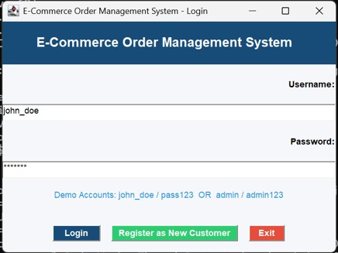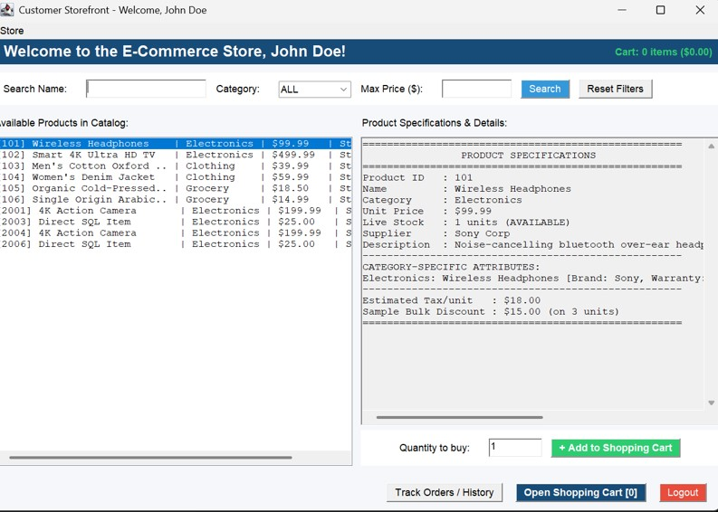
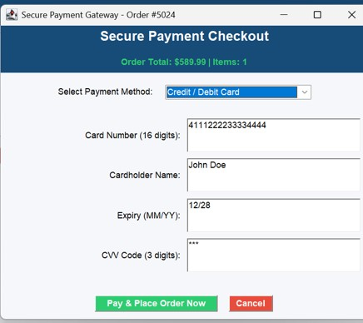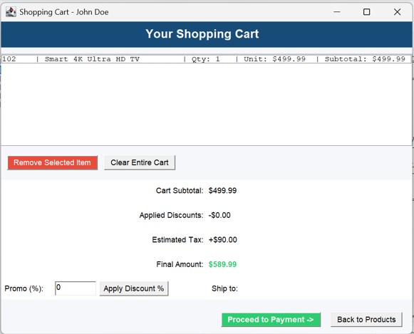

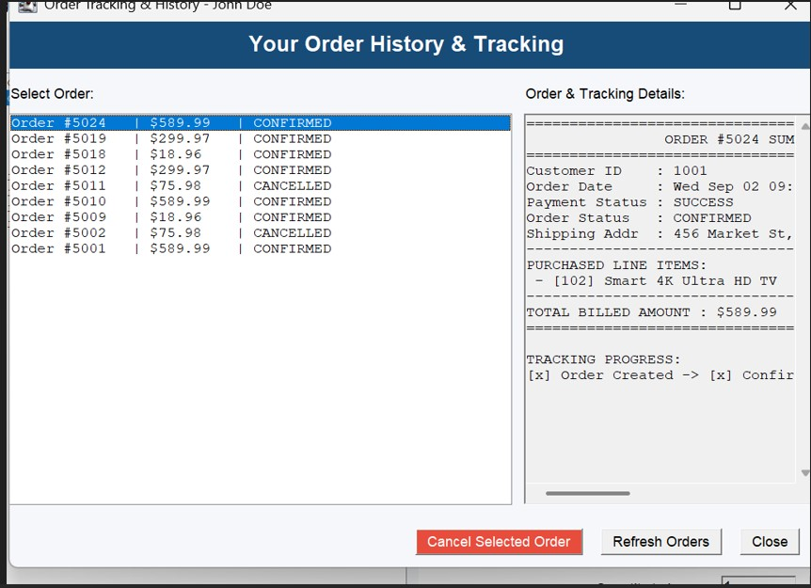

GitHub Link
Project Repository:
https://github.com/nanubalasudheer-wq/CSA0914.git

